**AP Computer Science Principles** Name: Thomas Achatz

**Activity 1.1.2: Introducing App Inventor**

Learning Target: Develop, construct, and analyze a working model/prototype addressing the given problem.

|  |  |  |  |  |
| --- | --- | --- | --- | --- |
| **A** | **B** | **C** | **D** | **IE** |
| Sliders and clear button have been added and work with expected results. | Sliders have been added and work with expected results. | Sliders have been added and work with occasional unexpected results. | Elements have been added, but work with unexpected results. | Not enough evidence of proficiency. |

Learning Target: Define the problem and analyze research to create a solution to a problem.

|  |  |  |  |  |
| --- | --- | --- | --- | --- |
| **A** | **B** | **C** | **D** | **IE** |
| Variables and roles are accurately defined. | Variables and roles are accurately defined, with minor error. | Some variables and roles are accurately defined. | Some variables and roles are accurately defined, with minor error. | Not enough evidence of proficiency. |

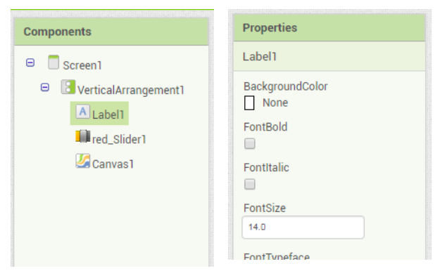

1. In the components panel, click on the Label 1 component as shown below on the left. The properties panel will show all the properties of that Label1 component.

What is the value of the Text property of the Label

Component?

“Drag Below to Draw Circles”

2. What is the value for each property of the red_Slider1 component? Fill in the table below with the values and what they mean.

|  |  |  |
| --- | --- | --- |
| Property | Value | Meaning |
| ColorLeft | Red | The color that’s displayed on the slider to the left of the position indicator. |
| ColorRight | Black | The color that’s displayed on the slider to the right of the position indicator. |
| MaxValue | 255 | 255 is the max value that a byte can hold and is used as a cap for any RGB value. |
| MinValue | 0 | 0 is the lowest value that a byte can hold and is the lowest number an RGB value can use. |
| ThumbPosition | 127 | 127 is around the middle of 255 so when the position indicator is generated it would be defaulted to the middle of the RGB bar. |
| Visible | True | This determines whether or not the user can see this element. |
| Width | Fill parent | This makes the width the highest possible value. |